Contact:  Candace G. Antinarella, MMC  City Clerk  (251) 620-1000  cityclerk@daphneal.com  1705 Main Street  Daphne, AL 36526  www.daphneal.com |  | 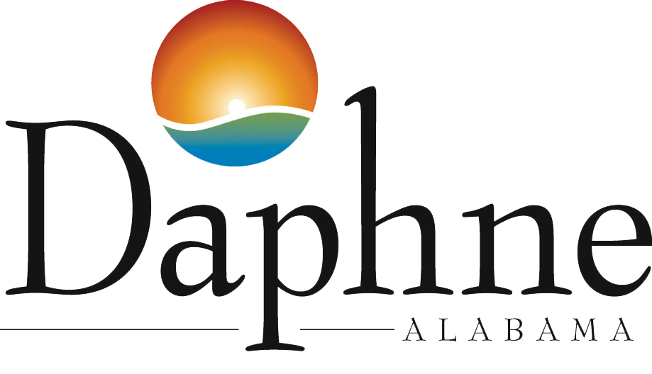

PUBLIC NOTICE

Special Called Council Meeting – April 10, 2025

Daphne, AL: The Daphne City Council has called a Special Called Council Meeting on Thursday, April 10, 2025 at 5:00pm in City Council Chambers.

This meeting is scheduled to declare a State of Emergency due to the recent flooding and anything else deemed necessary.

City Council Chambers is located at Daphne City Hall, 1705 Main Street, Daphne, Alabama.

